_{NIKE AIR MAX EXCEE}
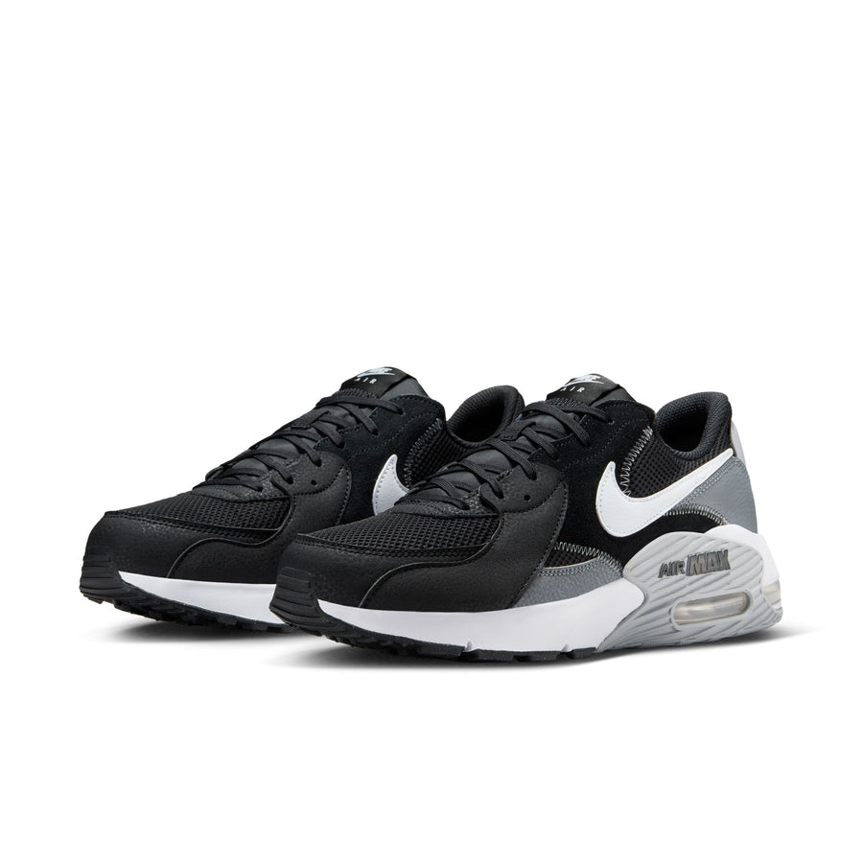
PRICE: Approximately Rs. 21,999

_{Introduction:}
The Nike Air Max Excee is a modern lifestyle sneaker inspired by the iconic Air Max heritage, designed to deliver everyday comfort with a bold, contemporary look. Built for all-day wear, this shoe features visible Air cushioning that provides lightweight support and impact protection with every step. Its sleek design blends sporty performance with street-ready style, making it an ideal choice for casual outings, daily routines, and light activities. With premium materials and Nike’s signature attention to detail, the Air Max Excee offers durability, breathability, and a timeless aesthetic that fits effortlessly into any wardrobe.
Product Overview:
The Nike Air Max Excee combines classic Air Max elements with a refreshed silhouette for a modern feel. Featuring a breathable upper and a cushioned midsole, it ensures lasting comfort while maintaining a stylish profile.
About the Brand:
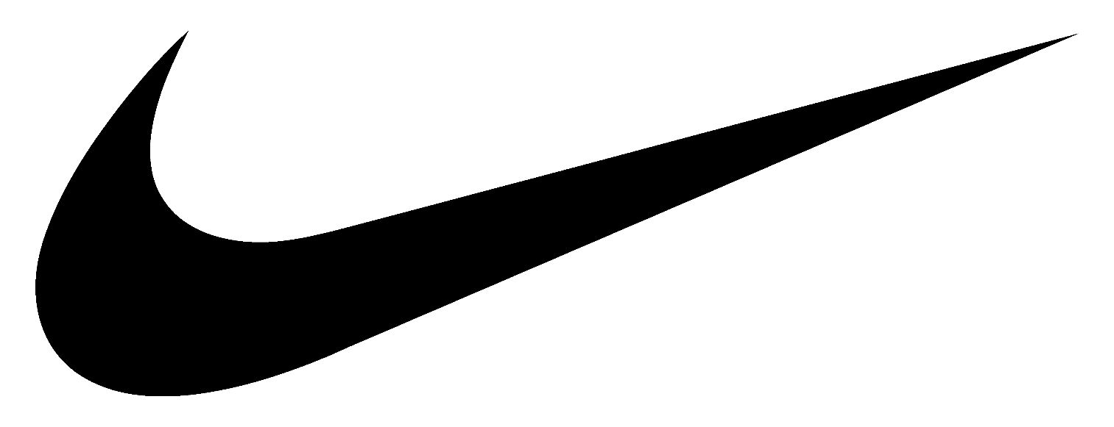
Nike is a world-leading sportswear brand known for innovation, performance, and iconic design. With decades of experience in athletic footwear and apparel, Nike continues to set global standards in comfort, durability, and style for athletes and lifestyle users alike.

Key Features:
- Eliminates odor caused by sweat and
- Visible Air Max cushioning for impact absorption
- Lightweight midsole for all-day comfort
- Breathable mesh upper with synthetic overlays
- Durable rubber outsole for reliable traction
- Modern design inspired by classic Air Max models

Design & Build Quality:
The Nike Air Max Excee features a sleek low-top design with clean lines and layered materials that enhance both style and durability. Reinforced stitching and quality construction ensure long-term wear, while the visible Air unit adds a distinctive, sporty edge to the overall look.
Storage & Capacity:
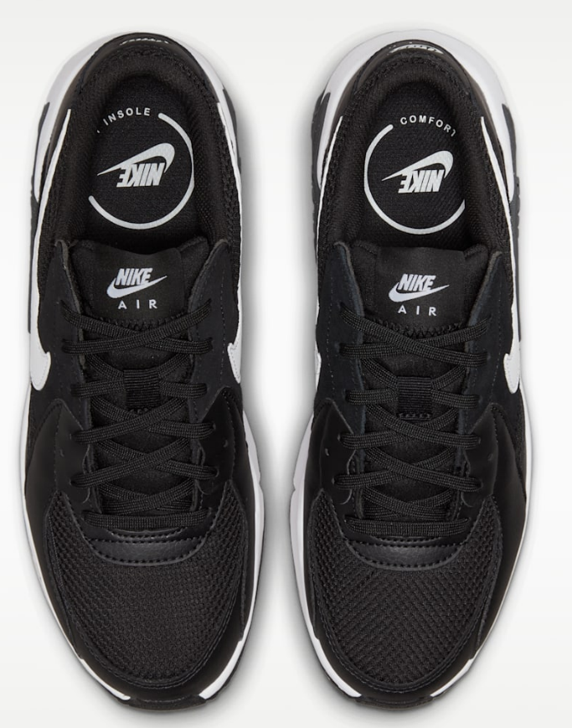
The shoe is designed to fit standard foot sizes comfortably, offering a secure lace-up closure for a snug fit. Its lightweight construction makes it easy to carry in gym bags or luggage, suitable for daily wear and travel.

Material & Durability:
Crafted from breathable mesh combined with synthetic overlays, the Nike Air Max Excee provides flexibility, airflow, and strength. The rubber outsole is built to withstand regular use, ensuring durability and consistent performance over time.
Ideal For:
- Everyday casual wear
- Light walking and daily activities
- Lifestyle and streetwear styling
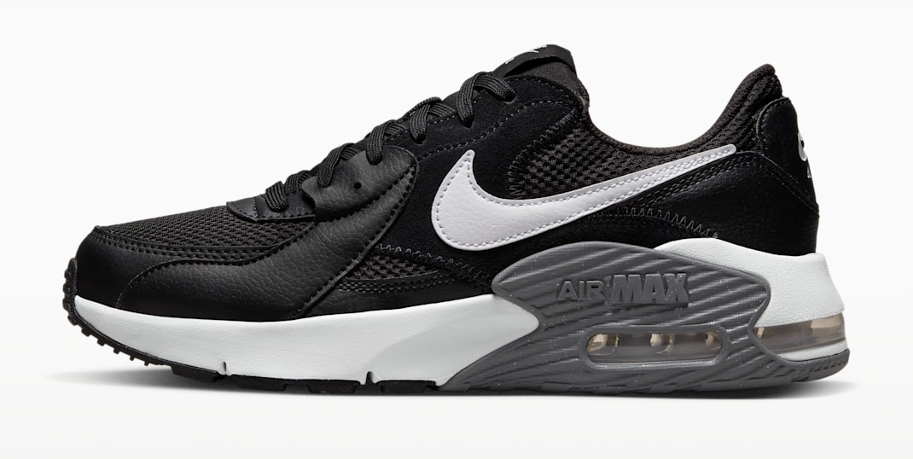
- Users seeking comfort with modern design

Care Instructions:
- Clean with a soft brush or damp cloth
- Avoid machine washing
- Air dry away from direct heat or sunlight
Product Specifications:
- Brand: Nike
- Model: Air Max Excee
- Type: Lifestyle Sneakers
- Upper Material: Mesh + Synthetic
- Midsole: Cushioned foam with Air unit
- Outsole: Rubber
- Closure: Lace-up
- Sizes Available: US 6–12 (approx.)
Product Summary:
The Nike Air Max Excee delivers classic Air Max comfort with a modern twist. Designed for everyday wear, it combines lightweight cushioning, durable materials, and a stylish silhouette, making it a reliable and fashionable choice for daily use.

